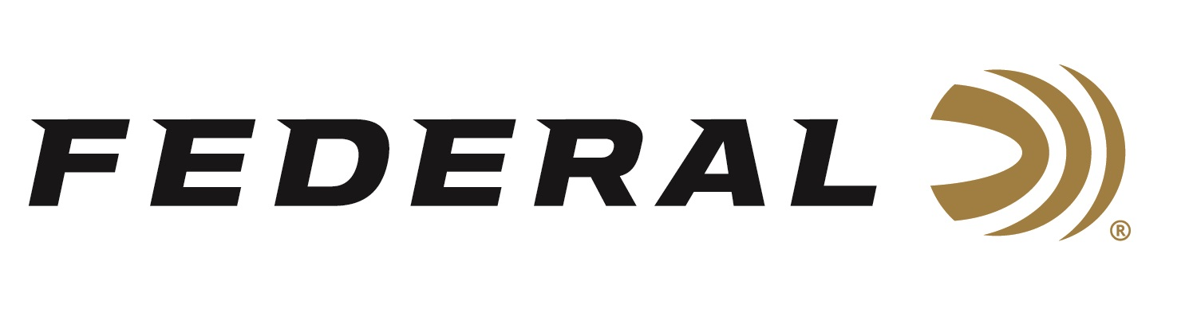

FOR IMMEDIATE RELEASE

**Team Federal Wins Titles at 2024 World Skeet Championships**

**ANOKA, Minnesota – October 14, 2024 –** Federal Ammunition congratulates sponsored skeet shooters Connor Ball, Jason Ward, and Stuart Brown on claiming world titles at the World Skeet Championships. The event was held September 27-October 5, 2024, at the National Shooting Complex in San Antonio, TX.

Connor Ball was the 2024 World Champion in the 20-gauge event. The 2022 HOA World Champion earned his way into this year’s 20-gauge shoot-off by breaking 100 straight and then bested thirty other title seekers in a shoot-off to win the coveted World Championship. This is his first gauge specific World Championship at the World Skeet Championships.

Jason Ward, the 2017 HOA World Champion, was victorious in this year’s .410 bore World Championship competition. Ward shot 100 straight to earn his way into a shoot-off before defeating seven other competitors. Ward finished fifth in the 2024 HOA World Championship. This year’s individual gauge specific title in the .410 bore adds to his list of victories including the 2017 and 2020 28-gauge titles and a 2019 win in the 20-gauge World Championship.

Finally, Stuart Brown won the Doubles World Championship. After shooting 100 straight, Brown emerged with the World Championship by defeating six other shooters, including teammate Connor Ball in a shoot-off. Brown was the HOA World Champion in 2016.

“Team Federal had an excellent showing at the World Championships,” said Mike Hampton, Sr., Federal’s shotshell team manager. “Bringing home three World Championships is a credit to the team’s hard work this season,” says Hampton.

Shotgunners on Team Federal use Federal Premium Gold Medal, High Over All and Top Gun shells, all designed to shoot smoothly and produce dense, uniform shot patterns that turn clay pigeons to dust.

Federal is the number one choice for shotgun shells and manufactures products in America for all competitive and recreational disciplines. See the full lineup, including the latest High Over All, at [www.federalpremium.com](http://www.federalpremium.com).

Federal ammunition can be found at dealers nationwide. For more information on all products from Federal or to shop online, visit [www.federalpremium.com](http://www.federalpremium.com).

**Press Release Contact: JJ Reich**

Senior Manager – Press Relations

E-mail: [media@tkghunt.com](mailto:media@tkghunt.com)

**About Federal Ammunition**

Federal, headquartered in Anoka, MN, is an ammunition brand of The Kinetic Group. From humble beginnings nestled among the lakes and woods of Minnesota, Federal Ammunition has evolved into one of the world's largest producers of sporting ammunition. Beginning in 1922, founding president, Charles L. Horn, paved the way for our success. Today, Federal carries on Horn's vision for quality products and service with the next generation of outdoorsmen and women. We maintain our position as experts in the science of ammunition production. Every day we manufacture products to enhance our customers' shooting experience while partnering with the conservation organizations that protect and support our outdoor heritage. We offer thousands of options in our Federal Premium and Federal® lines-it's what makes us the most complete ammunition company in the business and provides our customers with a choice no matter their pursuit.